THE BIG PROJECT - PHASE 01 (B01-B04)
EXTENSION OF TIME (EOT)
TIME IMPACT ANALYSIS REPORT
Technical Schedule Impact Assessment and EOT Quantification
TIME IMPACT ANALYSIS | FRAGNET | CRITICAL PATH | EOT QUANTIFICATION
CONTRACTOR | SAMCO
Client | ROYA
Engineer | ACE Project Management / ROYA
ISSUE STATUS | For Client/Engineer Review and Determination
ISSUE DATE | 06 July 2026
DOCUMENT TYPE | EOT Technical Schedule Assessment

`
Contents
1) Executive EOT Position 2
a. Basis of Analysis and Methodology 2
b. Data Reconciliation Controls 2
c. Key Findings 3
2) TIA Delay Events Under Assessment 4
3) Time Impact Analysis - Master Timeline Gantt 4
4) Concurrency Analysis – Delay events Driving EOT 5
EV01 - Steel Supply Cause and Effect 6
EV02 - Revised IFC Cause and Effect 7

Executive EOT Position

VERIFIED EVENT-LEVEL IMPACTS | INTEGRATED P6 CONTROL
117  EV01 BATCH 02  12-May-2027 → 06-Sep-2027  TF: -32 → -149 | 76  EV02 REVISED IFC  06-Jul-2027 → 20-Sep-2027  TF: -87 → -163 | 131  NET CROSS-WINDOW  12-May-2027 → 20-Sep-2027  Working integrated movement
Data Date 26-DEC-2025  Batch 01 comparison: 0 days | Data Date 17-Mar-2026  Ground Works movement: 78 days | Integrated milestone control  Not the arithmetic sum of event impacts
Figure 1 - Verified event-level impacts and consolidated working position.

Basis of Analysis and Methodology
The analysis applies a prospective Time Impact Analysis structure to the statused Primavera P6 schedule immediately before each event. The event-specific fragnet is inserted, the network is recalculated and milestone movement is measured. KD-MS-1050 Project Finish Date is the primary measure of EOT. KD-MS-1040 Ground Works Finish Date is reported as an intermediate milestone effect.
The schedule model retains the original construction predecessor and successor logic and adds event gates only to activities demonstrably dependent upon steel availability or revised IFC submittal and approval. Event duration is not automatically equal to EOT. The EOT is the calculated movement of the controlling project completion milestone after network recalculation.

Data Reconciliation Controls
TIA MODEL VALIDATION CHECKLIST | EDITABLE QUALITY CONTROL
Test | Requirement | Evidence / Check | Status
Data date | Update immediately before each event | 31-Oct / 26-Nov / 17-Mar windows | VERIFIED
Logic integrity | Original predecessor / successor logic retained | Event gates added only to affected activities | VERIFIED
Fragnet linkage | FS gates and approval releases are traceable | Relationship and successor reports required | VERIFIED
Recalculation | Schedule recalculated after each insertion | KD-MS-1040 and KD-MS-1050 compared | VERIFIED
Criticality | Completion movement measured at Project Finish | Float deterioration supports controlling effect | VERIFIED
Concurrency | Resequencing and overlapping delays assessed | Narrative and native updates to be submitted | VERIFIED

Key Findings
- Two (2) employer-risk delay events have been identified as a EOT driven after the insertion of dedicated fragnets into the contemporaneous schedule.
- Event 01 — Steel Supply Delay (Batch 02 Part 02) is EOT driving, causing a 117-calendar day extension to the project completion date.
- Event 02 — Revised IFC Drawings is EOT driving, causing a 76-calendar day extension to the project completion date.
- A concurrent overlap of 62 calendar days exists between the impact periods of Events 01 and 02.
- The net EOT entitlement is 131 calendar days, extending the project completion from 12-May-2027 to 20-Sep-2027.

TIA Delay Events Under Assessment
Employer / Engineer Risk Events Included in the Current Time Impact Analysis
Event | Data Date | Milestone | Before Fragnet | After Fragnet | Finish  Movement | Float  Movement
EV01 - Late Free-Issue Reinforcement Steel  (Batch01 - Employer's Materials) | 31-Oct-2025 | Project Finish | 14-Apr-2027 | 14-Apr-2027 | 0 days | -4 to -4
EV01 - Late Free-Issue Reinforcement Steel  (Batch02 - Employer's Materials) | 26-Nov-2025 | Project Finish | 12-May-2027 | 06-Sep-2027 | 117 days | -32 to -149
EV02 - Revised IFC Drawings / Instructions  (Resultant Rework and Re-submission) | 17-Mar-2026 | Project Finish | 06-Jul-2027 | 20-Sep-2027 | 76 days | -87 to -163
EV03 - Additional MEP Activities  (Variation / Change in Scope) | 25-Dec-2025 | Project Finish | 12-May-27 | 12-May-27 | 0 | -32 to -32
EV04 - Delayed RFI Response  (Delayed Information / Required Instructions) | 14-Feb-2026 | Project Finish | 06-Jul-27 | 06-Jul-27 | 0 | -87 to -87

Time Impact Analysis - Master Timeline Gantt
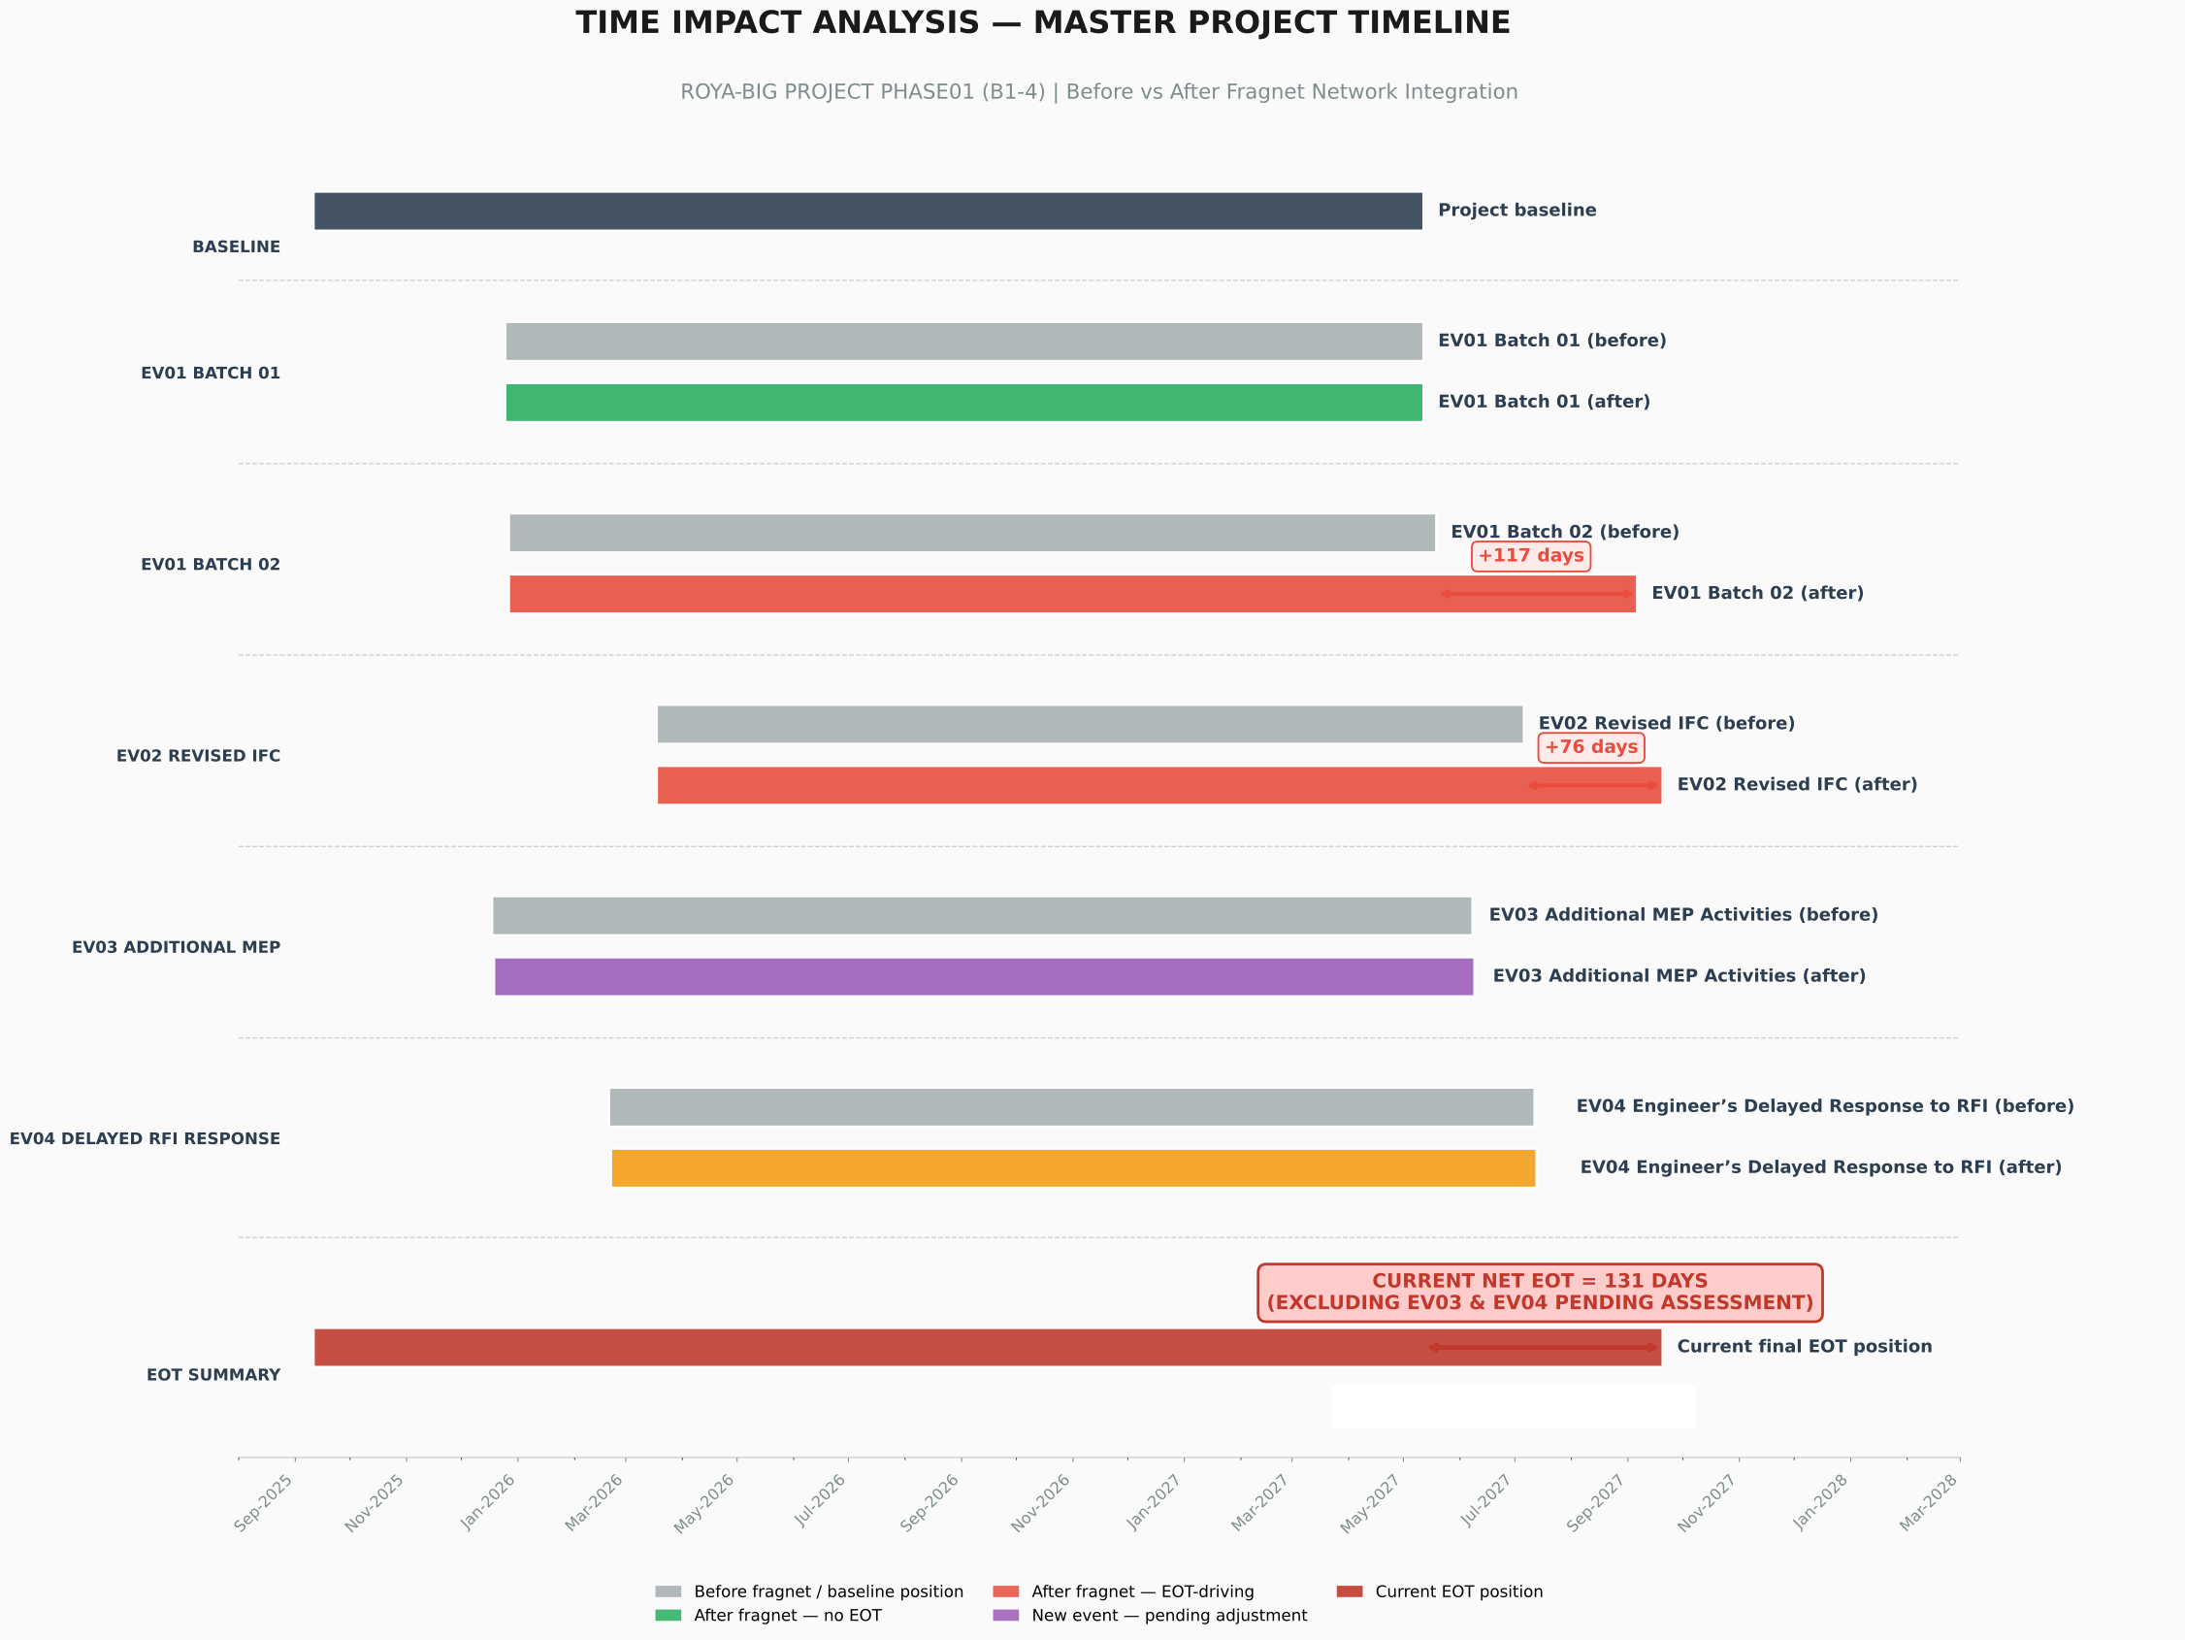

Concurrency Analysis – Delay events Driving EOT
In accordance with the principles established in the Society of Construction Law (SCL) Delay
and Disruption Protocol (2nd Edition, 2017), and consistent with the FIDIC contractual framework,
concurrent delay is recognized where two or more independent delay events arise at different
times but their effects are felt, in whole or in part, at the same time. The impact periods of
Event 01 (Batch 02) and Event 02 overlap between 6 July 2027 and 6 September 2027, representing
a concurrent overlap of sixty-two (62) calendar days.
Under the FIDIC Conditions of Contract, the Contractor is entitled to an extension of time for
Employer-risk events that delay completion, subject to the proper application of concurrent delay
principles. The gross delay is the arithmetic sum of individual EOT impacts (117 + 76 = 193 days).
The concurrent overlap of 62 days is absorbed to prevent double-counting of overlapping impacts.

Accordingly, the Net Extension of Time entitlement is calculated as follows:

Net EOT = Gross Delay − Concurrent Overlap
Net EOT = 193 days − 62 days
Net EOT = 131 calendar days

This calculation is independently verified by reference to the difference between the earliest
baseline Project Finish Date (12 May 2027, per Event 01 — Batch 01) and the final actual Project
Finish Date (20 September 2027), which yields an identical result of 131 calendar days.
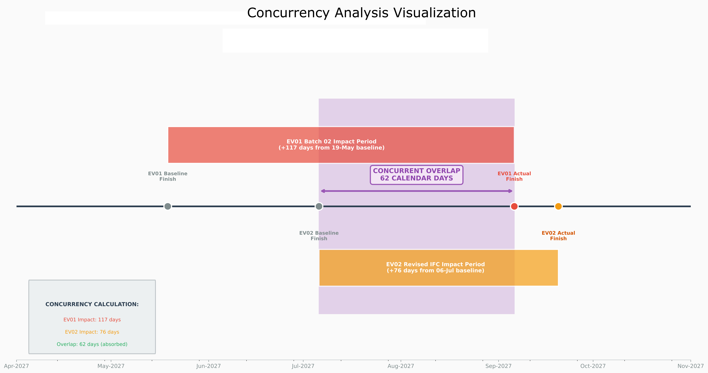

ENTITLEMENTEVENT 01

EV01 - Steel Supply Cause and Effect
EV01 CAUSE-AND-EFFECT PATH | EMPLOYER FREE-ISSUE STEEL
CONTRACT CAUSE  Employer steel obligation | → | P6 GATE  Batch 02 due 27-Dec-2025 | → | NON-AVAILABILITY  Steel not available as modelled | → | RELEASES  15-Feb partial / 05-May complete | → | WORK EFFECT  RFT gates release affected activities | → | DOWNSTREAM EFFECT  Concrete and structural works shift | → | MEASURED RESULT  Project Finish +117 days
CAUSE → GATE → RESTRICTION → RELEASE → DOWNSTREAM PROPAGATION → COMPLETION MOVEMENT
Figure 3 - Cause, schedule gate, work restriction and measured completion effect for EV01.
CAUSE-AND-EFFECT NARRATIVE
The contractual cause of EV01 is the non-availability of the Employer's free-issue reinforcement steel in accordance with the approved programme. In the 26-Nov-2025 statused schedule, Batch 02 was represented by a planned full-supply gate on 27-Dec-2025, a Part 01 partial-delivery milestone on 15-Feb-2026 and a Part 02 complete-delivery milestone on 05-May-2026. Because the steel gates were not satisfied on the planned date, the specifically identified reinforcement-fixing activities could not commence through their additional finish-to-start steel predecessors. The existing construction predecessor and successor logic was retained, so the restriction propagated from the affected footing, wall, slab, stair and ramp RFT activities into concrete and downstream structural works. Following network recalculation, KD-MS-1040 Ground Works Finish moved from 26-May-2026 to 29-Sep-2026, a movement of 126 calendar days. KD-MS-1050 Project Finish moved from 12-May-2027 to 06-Sep-2027, while total float deteriorated from -32 to -149 days. The event-level EOT effect demonstrated by the Primavera model is therefore 117 calendar days. The separate Batch 01 comparison produces no project-finish movement and is retained as chronology only, not as an additional EOT entitlement.

Milestone | Before Fragnet | After Fragnet | Movement | Float Movement
Ground Works Finish | 26-May-2026 | 29-Sep-2026 | 126 days | -15 to -141
Project Finish | 12-May-2027 | 06-Sep-2027 | 117 days | -32 to -149

EV02 - Revised IFC Cause and Effect
EV02 CAUSE-AND-EFFECT PATH | REVISED IFC DRAWINGS
REVISED IFC  18-Mar-2026 | → | DESIGN CONFLICT  Differences identified | → | CONTRACTOR NOTICE  24-Mar + RFI 02-Apr / 11-Apr | → | ENGINEER RESPONSE  14-Apr + 04-May / IFC 30-Apr
↓ CONFIRMED DESIGN BASIS → REWORK / RESUBMISSION → APPROVAL RELEASE ↓
REWORK  02-May to 02-Jun | → | 32 ACTIVITIES  16 submittals + 16 approvals | → | GROUND WORKS  28-Jul → 14-Oct (+78) | → | PROJECT FINISH  06-Jul → 20-Sep (+76)
CAUSE → NOTICE / RESPONSE → REWORK → APPROVAL RESTRICTION → STRUCTURAL SUCCESSOR SHIFT → COMPLETION MOVEMENT
Figure 4 - Cause, notice/response sequence, approval restriction and measured completion effect for EV02.
CAUSE-AND-EFFECT NARRATIVE
The cause of EV02 is the issue of a revised IFC structural package on 18-Mar-2026 that differed from the earlier design basis and required clarification, rework and renewed review of structural shop drawings. The Contractor recorded the conflict on 24-Mar-2026 and submitted RFI-STR-016 on 02-Apr-2026 and RFI-STR-017 on 11-Apr-2026. The Engineer's replies of 14-Apr-2026 and 04-May-2026, together with the revised IFC package transmitted on 30-Apr-2026, established the design basis to be followed. The Contractor then undertook shop-drawing rework and resubmission during the period 02-May-2026 to 02-Jun-2026. In the Primavera fragnet, this event was linked to 32 submittal and approval activities for beams and slabs in Basements 01 and 02 of Buildings B01-B04. The delayed approval cycle constrained the related structural construction successors. Following recalculation, KD-MS-1040 Ground Works Finish moved from 28-Jul-2026 to 14-Oct-2026, a movement of 78 calendar days. KD-MS-1050 Project Finish moved from 06-Jul-2027 to 20-Sep-2027, and total float deteriorated from -87 to -163 days. The event-level EOT effect demonstrated by the Primavera model is therefore 76 calendar days.

Milestone | Before Fragnet | After Fragnet | Movement | Float Movement
Ground Works Finish | 28-Jul-2026 | 14-Oct-2026 | 78 days | -78 to -156
Project Finish | 06-Jul-2027 | 20-Sep-2027 | 76 days | -87 to -163

